| **Section 1 – Practice Assessment Task Overview and Description** |
| --- |

# Student / Class Details

**Full name:** Basil Joseph

**Student ID:** 103328242

**Teacher:** Timothy Baird

**Date / Time started:** 10/11/2020 9:00 AM

Please read the whole assessment before starting, including the Summary of Evidence and Items / Criteria. Any missing files / an incomplete submission **will not be accepted,** and a resit will be required.

By checking the box below, you agree that penalties exist for plagiarized work, that all work submitted is your own and you have read the above statement. Please refer to the bottom of the document for more information on plagiarism.

I confirm that all work is my own and have read the entire assessment.

Case Study and tasks start on next page.

# Tasks

1. Write an algorithm that can print all numbers between 0 and 100. Attach a screenshot of this algorithm below. You may do this with a Flowchart or Pseudocode.
   1. Do not print any number that is divisible by 10. Eg: 10, 20, 30…
   2. Do not print any number that has a ‘3’ in it. Eg: 30, 13, 3, 53

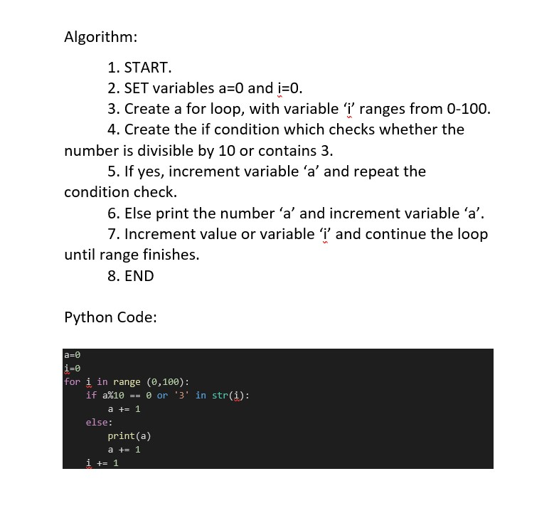

# Case Study

Dod&Gy have gathered a list of employees and their age from their company. Dod&Gy are rumoured to be very slack with their cybersecurity so they have decided to check their own! According to the rumours most employees still use the autogenerated password given to them at their employment. Dog&Gy have requested for you to help generate possible email / password combinations that will have been auto autogenerated so they can perform an attack on their system.

# Case Tasks

You have been provided with a sample file called ‘people.txt’, this file contains pipe (‘**|**’) separated details about employees at Huawow. The details included are their FirstName, LastName and Age respectively.

1. Using a python script:
   1. Read the provided people.txt file from Dog&Gy
   2. Generate a new file called ‘userpass.txt’.
   3. For every data entry generate a pipe (‘**|**’) separated email and password combo and append to the generated file. **Emails and passwords are case sensitive.**
      1. Remove / Ignore anyone over the age of 50
      2. Remove / Ignore anyone who’s name first starts with “b” (case insensitive)

Examples on the next page.

An example of the line by line output:

|  |  |
| --- | --- |
| **Input line (from people.txt)** | **Output line (to userpass.txt)** |
| *FirstName | LastName | Age* | *Email | Password* |
| Mary|Bill|54 | mbill@DodnGy.net|!1966BillM_ |
| Joe|feathers|32 | jfeathers@DodnGy.net|!1988FeathersJ_ |
| frank|Grasper|42 | fgrasper@DodnGy.net|!1978GrasperF_ |

End of Assessment.

| **Section 2 – Practice Assessment Task Submission Information** | |
| --- | --- |
| **Submission Details** | **Due date:** |
| 1. The assessment task must be submitted via Canvas or directly to the teacher with an assessment cover sheet. 2. Ensure to include on the front page or in the header or footer of your assessment:    * your name    * student ID    * your teacher’s name    * assessment agreement checked 3. Submissions received after the submission date must be approved by your teacher. 4. Incomplete submissions will not be accepted. |

| **Summary of Evidence to be Submitted** |
| --- |
| A Python script file (.py) with code representing the task at hand |
| The generated text file from your python script called ‘userpass.txt’ with all valid, pipe separated, email and password combinations |
| This assessment document with all form fields filled and the agreement checked |
|  |
|  |
|  |
| The task will be assessed as satisfactory when all the required evidence listed has been satisfactorily demonstrated.  * If applicable, for graded units, the task must be satisfactorily completed before marks will be allocated. Refer to your unit outline for more information. |

| Section 3 – Practice Assessment Task Criteria and Outcome | |
| --- | --- |
| *All items/criteria must be demonstrated satisfactorily to achieve this task. The items/criteria for this activity will be assessed as S – Satisfactory or US – Unsatisfactory.* | |
| Items/criteria | |
| 1. | Demonstrated understanding of reading and writing files in python |
| 2. | Demonstrated an understanding of python string methods - strip, split, lower and upper |
| 3. | Demonstrated an understanding of iteration over items using either a for or while loop |
| 4. | Developed an algorithm using Pseudocode or a Flowchart |
|  |  |

|  |  |
| --- | --- |
| **Section 4 – General Assessment Information** | |
| **Decision Making Rules** | Each activity in the assessment task must be satisfactorily completed for the task to be assessed as satisfactory.  Every task must be satisfactorily completed to be assessed as competent in the unit.  *\* For graded units, competence must be demonstrated before a mark can be given.* |
| **Plagiarism** | There are serious penalties for plagiarism that may include repeating a new assessment task or being withdrawn for the unit / course.  Students must ensure that all assessments are their own work (or group work and clearly noted as such).  Please refer to [www.swinburne.edu.au/corporate/registrar/plagiarism/index.html](http://www.swinburne.edu.au/corporate/registrar/plagiarism/index.html) |
| **Reasonable Adjustment** | Students may request reasonable adjustment for assessment tasks.  Reasonable adjustment usually involves varying:   * the processes for conducting the assessment (eg: allowing additional time, varying the venue) * the evidence gathering techniques (eg: oral rather than written questioning, use of a scribe, modifications to equipment)   However, the evidence collected must allow the student to demonstrate all requirements of the unit.  If you have any other issue that may impact your ability to undertake the assessment, please discuss with your teacher. |
| **Re-submission** *(where tasks are not satisfactorily completed)* | Assessment tasks that are not satisfactory can be resubmitted up until the end of the unit as scheduled on the Unit Outline. The timing on this may depend on the equipment required for this assessment task.  Resubmissions received after the scheduled unit end date may not be accepted unless approved by the teacher prior to the end date.  Note: Assessment tasks submitted for the first time after the unit end date as scheduled in the Unit Outline will not be assessed and the student should re-enrol into the unit. |
| **Special consideration** | Students may apply for Special Consideration where personal circumstances have adversely affected their task result or ability to undertake an assessment. A Special Consideration form can be completed prior to, but no later than 3 days after, the date of assessment and submitted to the relevant Manager. |
| **Work Health & Safety** | Activities may require the use of equipment or participation in group exercises. If the teacher identifies any unsafe activity or potentially dangerous situations, the teacher can stop the assessment at any time. |